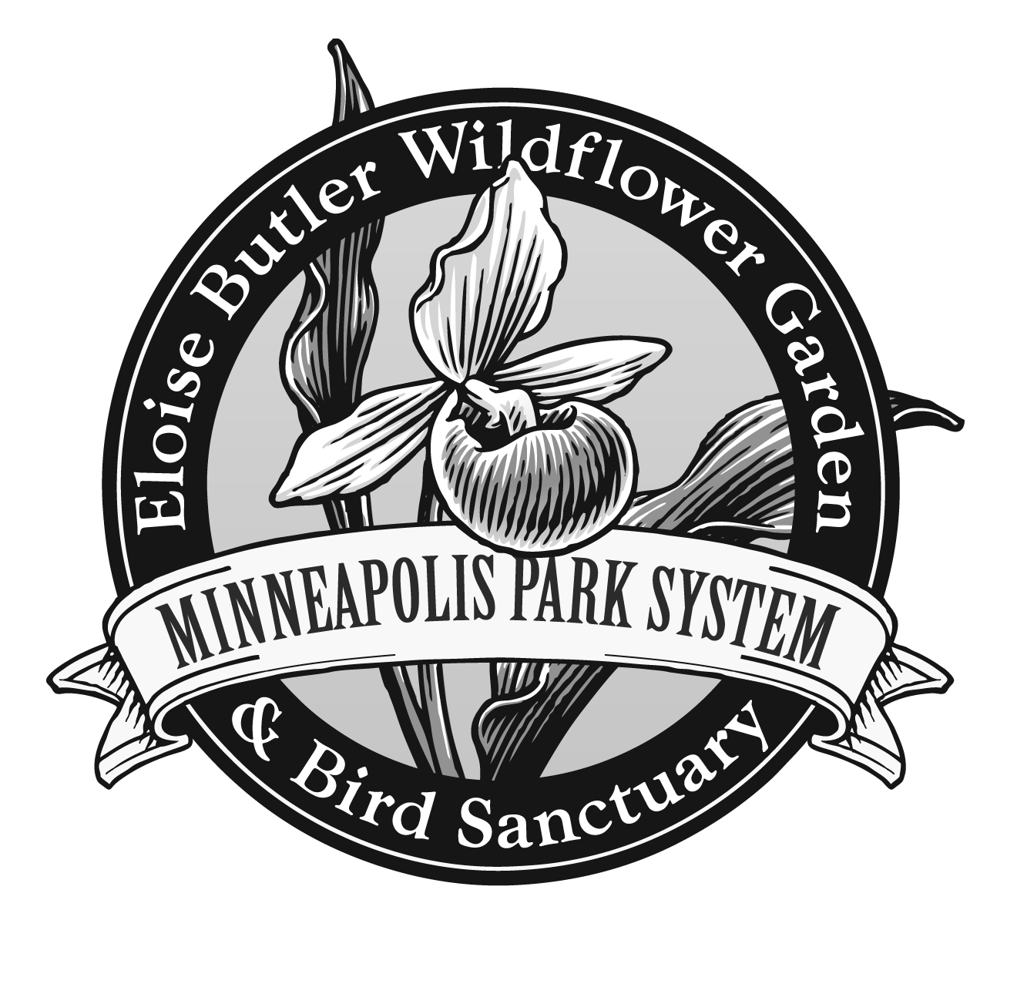

Eloise Butler Wildflower Garden & Bird Sanctuary

RULES OF THE GARDEN

The Garden is a sanctuary for plants, animals, and visitors alike. While visiting the Garden, treat the living things that make this area home with great respect. Here is a list of rules for our Garden:

- No picking or injuring any flower, grass, tree, shrub or animal
- No bicycle riding
- No walking off the trails
- No running
- No pets allowed
- Leave only footprints and take only photographs
- Dress for the weather and wear sturdy shoes for walking
- Come to the Garden ready to learn a little and have a lot of fun!

